COAL Lab Task 1

Name: Muhammad Affan Khan.

Roll no: P190045

Section: 5B

BSCS

Installation Process for MASM 32:

First open the following link:

<https://www.masm32.com/download.htm>

And after that we have to click on the Western Europe link and need to download the ZIP file.

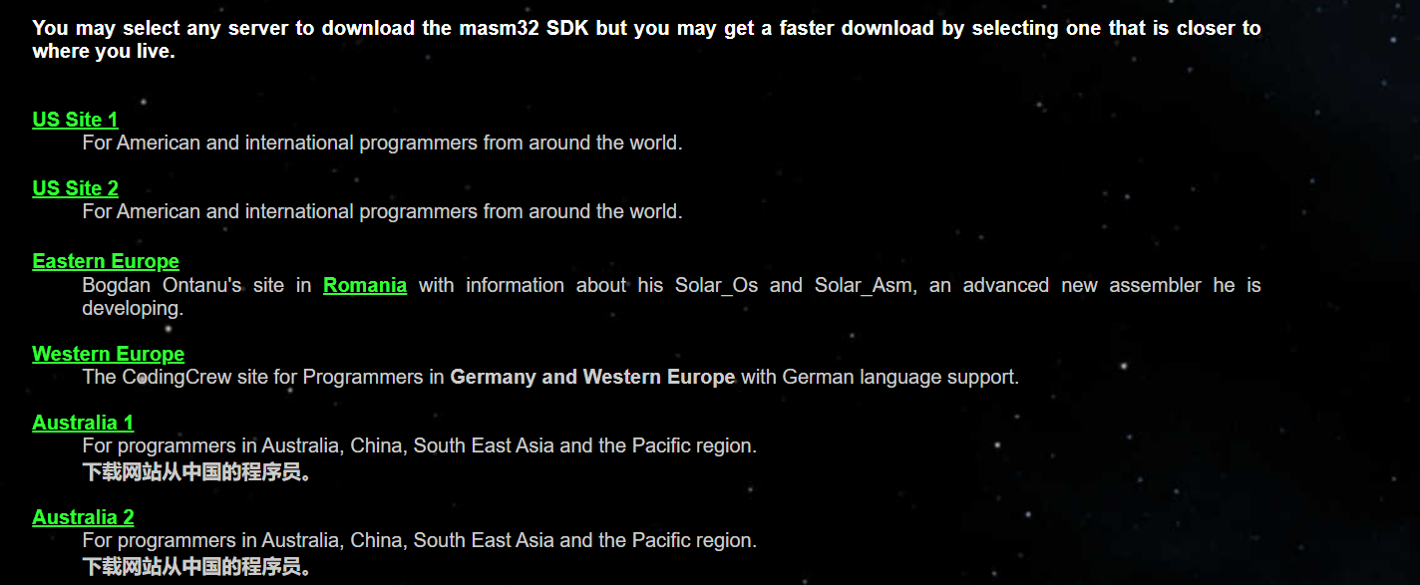

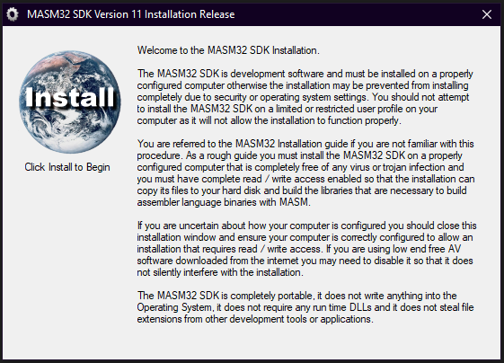Now click on install button.

Then click on the partition where u want to install this.

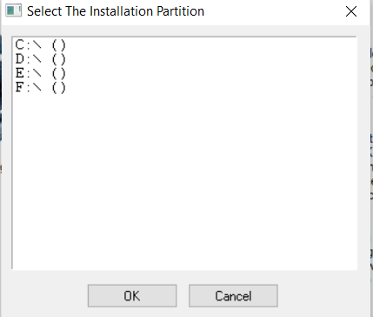

After accepting a partition such a window will come in front of us and will automatically work for 2-3 minutes.

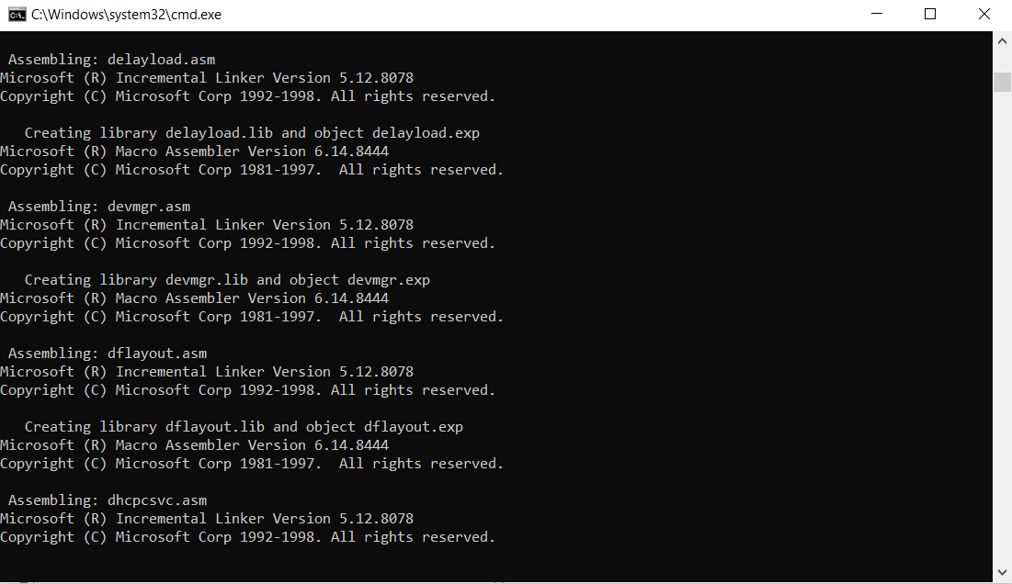

After the working is complete such a screen will come forward and u will have to erase all this and paste our code here.

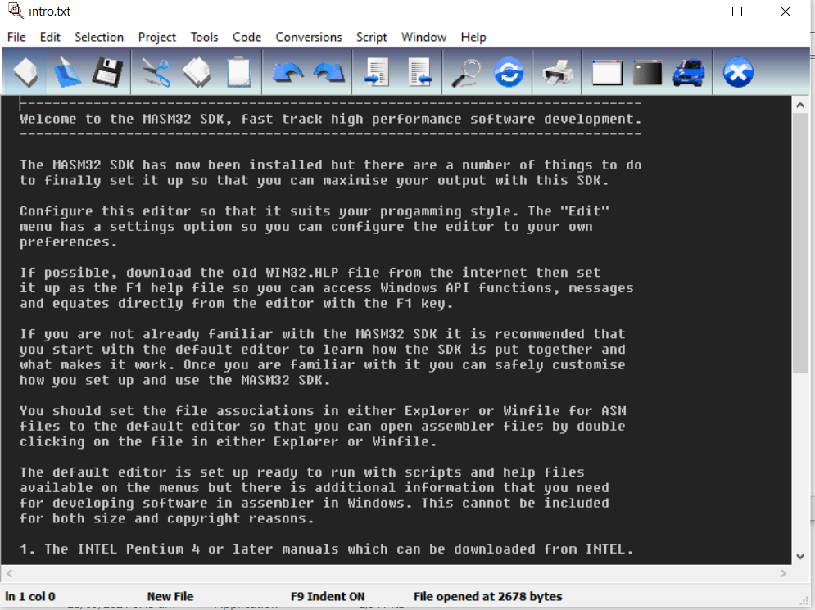

After pasting/writing our code on this, it will look like this.

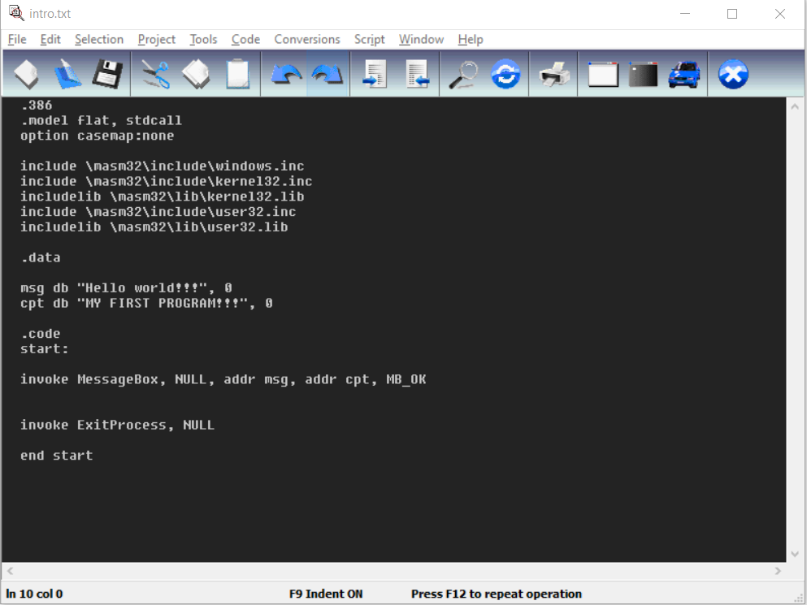

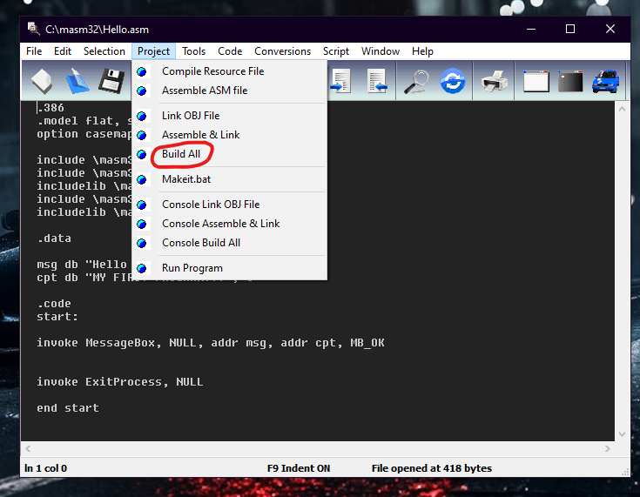Then u will click on build all .

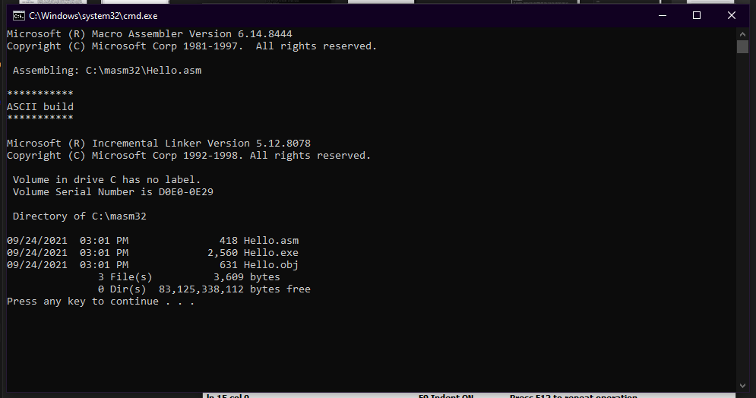And after this you will be able to see the following window.

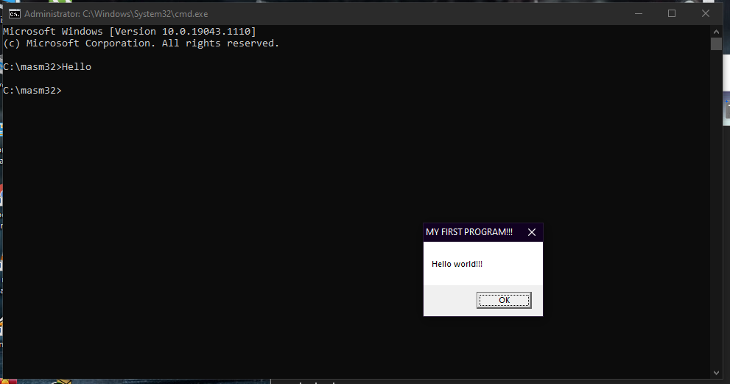Then press any key to close the window and then open command prompt and go to the masm folder and run the Hello.asm file and you will get the following window.

